(Approx. 432 words)

Navigation Tips for Windows 10
By Rosita Herrick, Forum Leader, Sarasota Technology Users Group, Florida
April 20918 issue, STUGMonitor
www.thestug.org
rherrick (at) aol.com

Now that Windows 10 has been around for a while, I thought that several tips to navigate this new operating system and make its use friendlier, are in order.

- Using the Quick Link menu Like most Windows options, there are two ways to get to this menu. One way is to right click the Windows icon in the lower left corner of the screen. The second way is to use the keyboard shortcut Windows Key + X. Each line in the displayed pop-up is a link to a system function. The item I use most are the Shut down or Sign out (lower part) when I am done for the day. I also use the Task Manager link if the computer slows down, and lately, the Run link that lets me check what version of Windows I am running,

Here is the result when I click on the OK button:
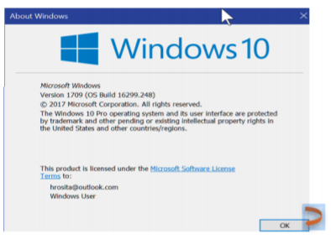
- Need to do some cleanup to remove old update files, system dumps from crashes and/or Windows log files?

Here are the steps:
Type Cleanmgr in the Cortana search box.
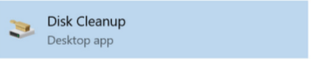
Click on the Disk Cleanup link.

Type OK in the displayed box and, in the next window, place checkmarks in the files you want deleted, and click OK.

- Enter a PIN number at logon.

Are you tired of entering a long, hard to type password when you logon or when the computer wakes up from sleep? Here is what you can do.

To create a PIN for logon, go to Settings, and click on the Accounts icon.
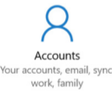
You can also enter Accounts in the Cortana search box.

Click on the Sign-in options link.

This is where you can setup your PIN, change your password, etc.
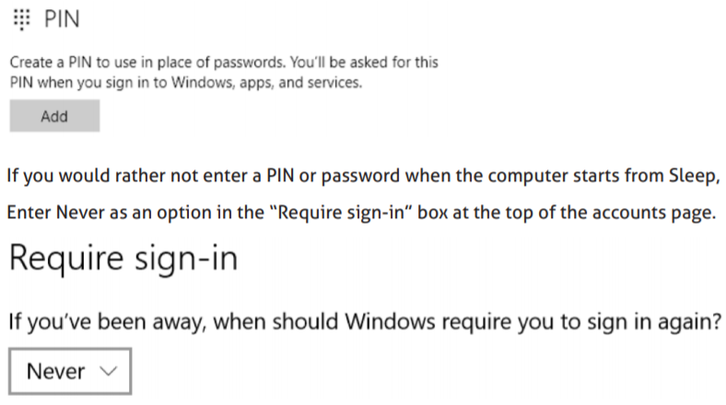
- Want to look at two screen windows side by side? Many a time I want to drag and drop a file or folder from one location to another. Here is an easy way. With both windows open, click on one screen and press the Windows key and the left arrow. The screen will move to the left of the screen. Now click on the other screen and press the Windows key and the right arrow. Here is how the two screens will look side by side:
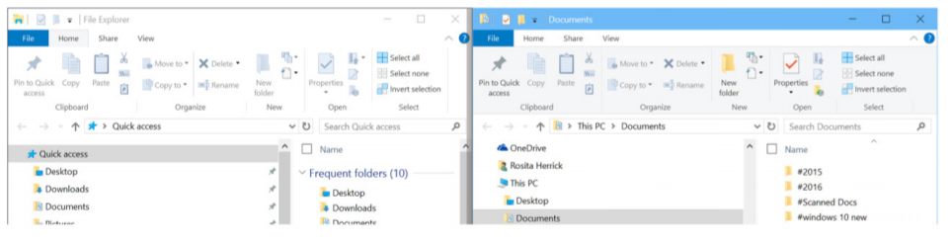
The left screen is the File explorer screen and the right screen is the Documents screen. I can now rearrange or move any file I want from one screen to another by dragging and dropping.

